Game Analysis Report

Animal Crossing: New Leaf

Index

I. Introduction 2

II. Controls 3

III. Mechanics, Dynamics, Aesthetics 4

IV. Conclusion 7

V. References 7

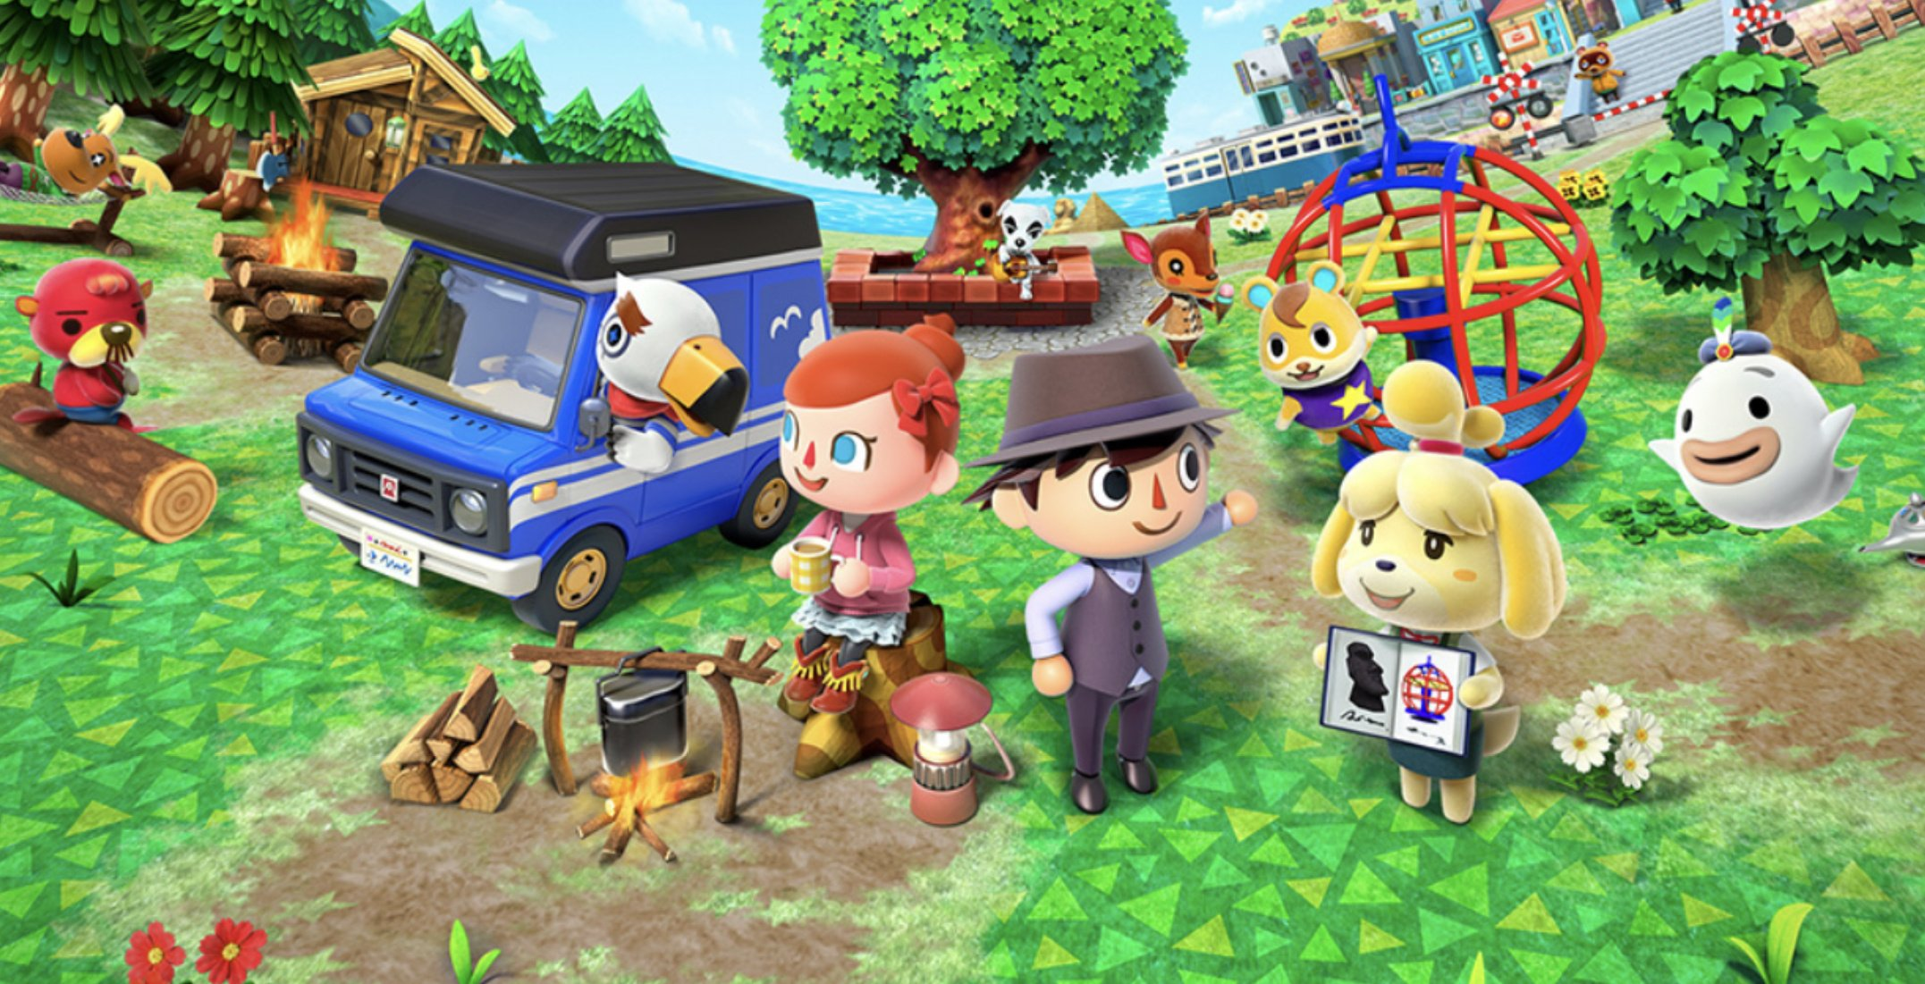

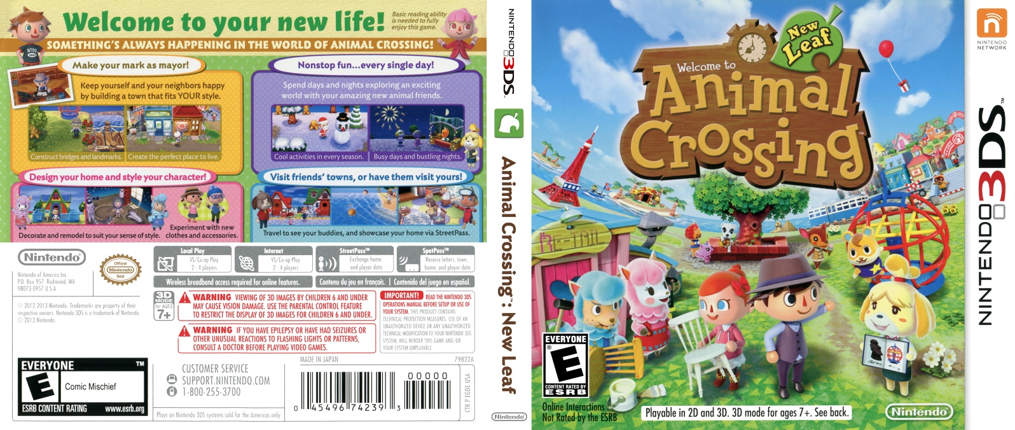

Figure 1 – Box Cover [1]

# Introduction

The game that I have chosen to write my game analysis report on is titled *Animal Crossing: New Leaf*. Developed and published by Nintendo, a Japanese electronics and video game company, it was first released in November 2012 for the Japanese market, later followed by its European release in June 2013. The fourth game in the *Animal Crossing* series, *New Leaf* was designed for the Nintendo 3DS platform.

The following is the list of game releases in Nintendo’s *Animal Crossing* series, including the year of release, along with the platform each was designed for:

1. *Animal Crossing* (2001) for the Nintendo64, and the Nintendo GameCube
2. *Animal Crossing: Wild World* (2005) for the Nintendo DS
3. *Animal Crossing: City Folk* (2008) for the Nintendo Wii
4. *Animal Crossing: New Leaf (2012, 3DS)* for the Nintendo 3DS
5. *Animal Crossing: New Horizons* (2020) for the Nintendo Switch

In addition to the main series, a number of spin-off games have been released:

1. *Animal Crossing: Happy Home Designer* (2015) for the Nintendo 3DS
2. *Animal Crossing: Amiibo Festival* (2015) for the Nintendo Wii U
3. *Animal Crossing: Pocket Camp* (2017) for mobile

The *Animal Crossing* series falls into the genre of life simulation gaming. The player, a human, takes on the role of a town Mayor, the townsfolk of which are anthropomorphic animals. According to the game’s blurb on Nintendo’s website, *“No matter how you play it, this is the perfect time to cozy up to the charm and creativity of this special game. New friends and discoveries await every day. Express yourself by customizing your character, home, and town as you create your ideal world*. [2]

# Controls

*New Leaf* is played on the Nintendo 3DS, a handheld console. The player can walk, changing direction using either the C-pad (circle pad) or the D-pad. Running is possible by holding either the B button, or one of the L/R buttons, while pressing the movement sticks. The A button performs actions, and is used to talk to villagers, to use equipped tools, to shake trees, to enter buildings, etc. When held, the player can pull/push/rotate furniture inside their house. The B button is used to pick up items, pick flowers, or to close a menu. The player can also use the touchscreen and stylus on the 3DS. Here, the town map can be viewed, along with other menus.

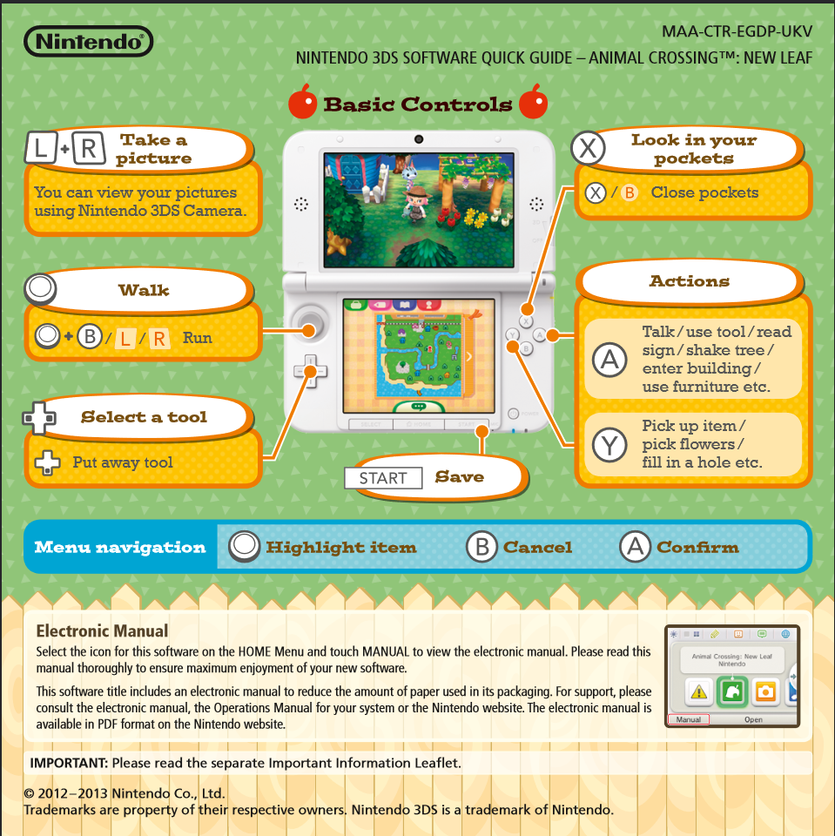

Figure 2 – Basic Controls, as shown in the *New Leaf* manual [3]

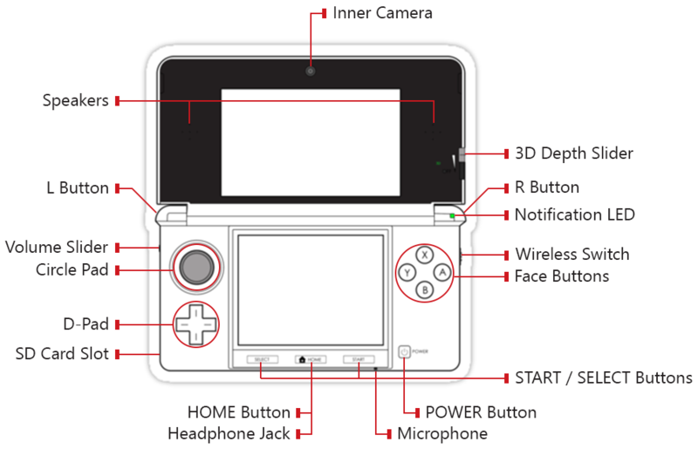

Figure 3 – Nintendo 3DS Layout and Button Controls [4]

# Mechanics, Dynamics, Aesthetics

*New Leaf* opens with a scene on a train, where the player is asked for their name, and town name. Upon arriving at the seaside town, they are welcomed by the town’s citizens, and congratulated on the player’s position of Mayor. The character Isabelle introduces herself as the Mayor’s secretary, offering help and assistance, talking the player through the initial setup.

Roleplaying as Mayor, the player has some control over the town and its layout. The Public Works Projects enables the Mayor to add new buildings and upgrade existing buildings, as well as erecting statues, landmarks, and other such public decorative features. In order to avail of this part of the gameplay, the Mayor must first achieve 100% satisfaction rating from the town citizens. This can be done by unlocking new shops in Main Street, picking weeds, planting flowers, and befriending the citizens. The game allows you to explore social interactions with your villagers, nurturing friendships through chatter, and mini errands given to you. Villagers can talk amongst themselves, often times recalling these interactions when talking to the player. This helps to create a sense of community within the game. New projects can be requested by talking to villagers who exhibit the “Surprised” emote reaction.

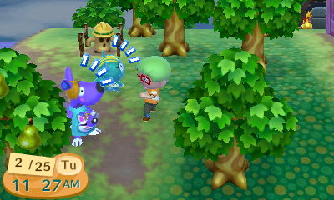

Figure 5 – Villagers Showing a Reaction [5]

When the Mayor chooses to begin a project, the player has the option to choose the location. Construction fencing is set up in the designated area, and funds must be donated before the project is completed. Villagers in the town can donate, although only a small amount each day, therefore it is up to the player to contribute the vast majority of the funds. This game mechanic encourages the player to spend their money wisely, as demolition of a finished project requires a 10% fee of the original cost. It also encourages town planning, as the player may want to design their town in such a way that it is a beautiful landmark, or simply by making it efficient to travel around, having a clear path between most visited areas.

There are a number of permanent buildings in the town, simulating real life. The Town Hall is where Isabelle can be found. Here, the player can check the town’s rating, change the town tune music, or report problematic villagers.

On Main Street, the Post Office allows you to send letters. It also acts as a bank. The player can access their savings account via the Automatic Bell Dispenser (ABD), depositing or withdrawing Bells, the in-game currency. The ABD is also where the player can pay off their house debt to Tom Nook. Similar to a real-life bank account, the player receives interest on their Bells each month. Again, this gameplay mechanic encourages the player to save their money, rewarding them if they do, rather than spending it all on other items or game features.

The player can upgrade their house, expanding their space as they progress through the game. You can customise the exterior design of your house at Nook’s Homes. Expanding your house will necessitate mortgage payments to Tom Nook. The interior of your house can also be customised. The player can purchase floor and wall designs, as well as the option of applying a custom-made pattern. There is a vast amount of furniture items available for purchase, often in matching sets, some of which can be customised using gem stones or custom-made patterns. In addition to this, special items can be obtained via events. Players can express themselves with how their house is designed and organised. Each and every item that the player has held in their possession over the course of the game is recorded in the catalogue. This feature encourages some players to become collective, setting a user-defined goal of collecting every item in the game.

Throughout the town, there are marks on the ground where fossils are buried. Using a shovel, these can be dug up. Upon doing this action, the player will remark on the type of fossil found, with a short description. This element can educate players. The fossils can be donated to the Museum, where they will be put on public display, paired with a plaque describing each exhibit. Bugs and fish can likewise be donated and displayed in the Museum. These can be collected by catching bugs with a net, and catching fish in rivers and the sea using a fishing rod. Additionally, art can be donated. Art pieces can be purchased in Crazy Redd’s Tent, a pop-up type store that appears in the town occasionally. The character Redd is known to be a con artist. His tent showcases four pieces of art, of which one is real, and three are fake. The player must deduce the authentic from the counterfeit, the latter of which will not be accepted in the Museum. The catalogue also records all fossils, bugs, fish, and art pieces collected by the player. This can be a goal the player focuses on while playing *New Leaf.* Completing a collection gives the player a sense of accomplishment.

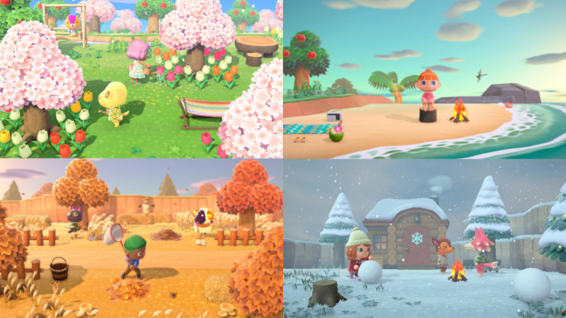

Figure 4 – Seasons within *Animal Crossing: New Horizons* [6]

Time in *Animal Crossing* games imitate real life. An in-game minute is the same as a real-life minute. There are day and night cycles, wherein the town looks different. Stores have opening and closing times. At night, a villager or two can be seen walking around outside, with most blocking entrance to their house as they are asleep. Bugs and fish are more/less common at certain times of day. In addition to this, the game also imitates seasons.

In summer, the trees and grass are their most vibrant shade of green. The player’s character can become sunburned if outside for long periods of time. In autumn, the trees begin to change colour to an orange-brown, and the grass becomes duller. In winter, snow appears atop trees and covers the ground. Players can create snowmen, and snowflakes fall instead of rain. In spring, cherry blossoms roam the landscape. Throughout the seasons, the weather varies to reflect seasonal changes, switching from sunny, cloudy, raining, and snowing, each to varying degrees of intensity.

*Animal Crossing* celebrates real-life holidays in its games, stemming from a mixture of cultures. New Year’s Day kicks off with fireworks. Festivale imitates *Mardi Gras*. The first full moon of the year gifts the player with *Bureom*, a Korean dish. To mark *Hinamatsuri*, a Japanese special day, the player is given a Rice Cake. For St Patrick’s Day, Shamrock hats are available. Easter, Halloween, and Christmas are honoured with their respective notable figures. [7]

The game utilises the internal system clock and calendar set by the user’s device. Should they choose, the player can “time travel” by adjusting their system settings, a controversial move, considered cheating by some within the community. This can be harmless in some situations – say you missed the store opening hours, you can opt to reverse the clock by an hour. However, the game can penalise you for repeatedly time travelling. Each time the game is loaded, the grass in the town deteriorates slightly. More weeds will grow, flowers can shrivel and die, the player may get “bed head”, cockroaches may appear in the player’s house, villagers may move out if they feel neglected. Nintendo created a character, Resetti, a cranky mole who appears when you start-up the game after resetting without saving. He acts as a parent who scolds their child, to varying levels in each instalment of the series. This is a reminder that life itself does not have an “undo” button; you cannot constantly reset when things go wrong.

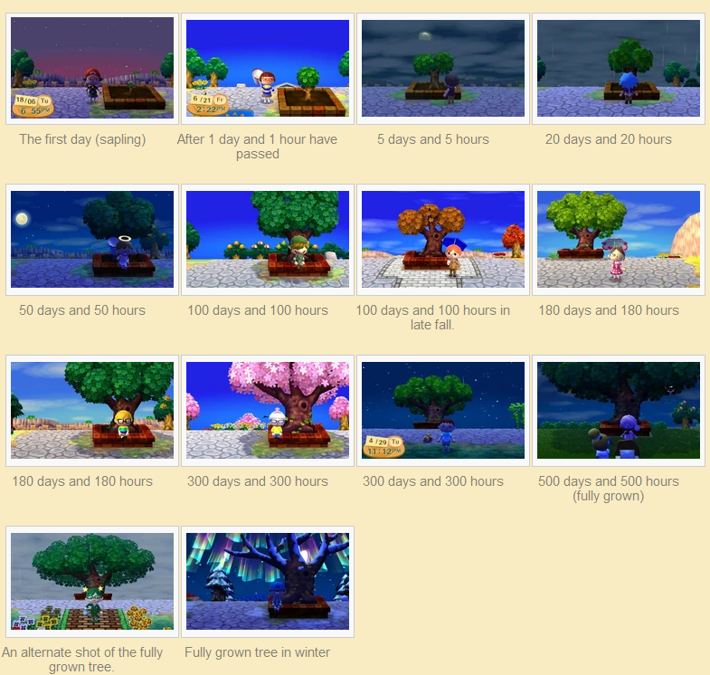

Figure 5 – Stages of the Town Tree [8]

In *New Leaf*, there is a permanent tree in the Plaza. On the first day of gameplay, it is small in size. As the players spends more time in the game, the tree grows progressively. After 500 days of gameplay, the tree will have grown to its maximum size. At the site of the fully-grown tree, the player can sit on the ledge, an action that will prompt the game credits to run. If the player sits as the tree is growing, a list of town achievements will be shown.

# Conclusion

*Animal Crossing: New Leaf* is a calming, fun, family-friendly game that simulates life in an environment that the player has control over. It is suited to those who enjoy open-ended gameplay, revolving around elements such as interior design, town planning, taking care of others, collecting items, and dressing your character. Worldwide, players have expressed that playing *New Leaf* has had a therapeutic effect on them – the peaceful gameplay can help to reduce stress, anxiety, and loneliness.

Partly due to the lockdowns imposed as a result of the COVID-19 pandemic, the newest instalment in the series was a roaring commercial success. Within the month of its release, *Animal Crossing: New Horizons* sold 11.77 million units, which is now the best start ever for a Nintendo Switch title. [9] As of 30 September, *New Horizons* (26.04 million) is the second best-selling video game for the Nintendo Switch, behind *Mario Kart 8 Deluxe* (28.99 million). [10]

In a timeline where people cannot visit each other’s houses in-person, life simulation games can offer a safe alternative. With its tagline “Welcome to your new life!”, the game bestows escapism into an idyllic world.

# References

1. Box Cover: <https://www.covercentury.com/index.php?p=3ds&l=a&f=3ds_animalcrossingnewleaf.jpg>
2. Game Blurb: <https://www.nintendo.com/games/detail/animal-crossing-new-leaf-3ds/>
3. Basic Controls: <https://cdn02.nintendo-europe.com/media/downloads/games_8/quick_start_guide/QuickStartGuide_3DS_AnimalCrossingNewLeaf_EN.pdf>
4. 3DS Layout: <https://en.wikipedia.org/wiki/File:Nintendo_3DS_Button_Map.png>
5. Reaction: <https://nookipedia.com/wiki/Reaction>
6. Seasons: <https://www.millenium.gg/guide/15579.html>
7. List of Holidays and Special Events: <https://www.thonky.com/animal-crossing-new-leaf/list-of-holidays-events>
8. Town Tree: <https://animalcrossing.fandom.com/wiki/Plaza>
9. Nintendo’s Operating Results and Financial Positions for the Fiscal Year Ended March 31, 2020: <https://www.nintendo.co.jp/ir/pdf/2020/200507e.pdf>
10. Nintendo’s Top Selling Title Sales Units: <https://www.nintendo.co.jp/ir/en/finance/software/index.html>